## 3-Terminal Regulators

**Output Current up to 1.5 A**

## Internal Thermal-Overload Protection

**KC (TO-220) PACKAGE (TOP VIEW)**

## High Power-Dissipation Capability

**Internal Short-Circuit Current Limiting**

## Output Transistor Safe-Area Compensation

**KTE PACKAGE (TOP VIEW)**

COMMON

OUTPUT COMMON INPUT



COMMON

**KCS (TO-220) PACKAGE (TOP VIEW)**

OUTPUT COMMON INPUT

OUTPUT COMMON INPUT



COMMON

# description/ordering information

This series of fixed-voltage integrated-circuit voltage regulators is designed for a wide range of applications. These applications include on-card regulation for elimination of noise and distribution problems associated with single-point regulation. Each of these regulators can deliver up to 1.5 A of output current. The internal current-limiting and thermal-shutdown features of these regulators essentially make them immune to overload. In addition to use as fixed-voltage regulators, these devices can be used with external components to obtain adjustable output voltages and currents, and also can be used as the power-pass element in precision regulators.

**ORDERING INFORMATION**

|  |  |  |  |  |  |
| --- | --- | --- | --- | --- | --- |
| **TJ** | **VO(NOM) (V)** | **PACKAGE†** | | **ORDERABLE PART NUMBER** | **TOP-SIDE MARKING** |
| C to 125C | 5 | POWER-FLEX (KTE) | Reel of 2000 | A7805CKTER | A7805C |
| TO-220 (KC) | Tube of 50 | A7805CKC | A7805C |
| TO-220, short shoulder (KCS) | Tube of 20 | A7805CKCS |
| 8 | POWER-FLEX (KTE) | Reel of 2000 | A7808CKTER | A7808C |
| TO-220 (KC) | Tube of 50 | A7808CKC | A7808C |
| TO-220, short shoulder (KCS) | Tube of 20 | A7808CKCS |
| 10 | POWER-FLEX (KTE) | Reel of 2000 | A7810CKTER | A7810C |
| TO-220 (KC) | Tube of 50 | A7810CKC | A7810C |
| 12 | POWER-FLEX (KTE) | Reel of 2000 | A7812CKTER | A7812C |
| TO-220 (KC) | Tube of 50 | A7812CKC | A7812C |
| TO-220, short shoulder (KCS) | Tube of 20 | A7812CKCS |
| 15 | POWER-FLEX (KTE) | Reel of 2000 | A7815CKTER | A7815C |
| TO-220 (KC) | Tube of 50 | A7815CKC | A7815C |
| TO-220, short shoulder (KCS) | Tube of 20 | A7815CKCS |
| 24 | POWER-FLEX (KTE) | Reel of 2000 | A7824CKTER | A7824C |
| TO-220 (KC) | Tube of 50 | A7824CKC | A7824C |

† Package drawings, standard packing quantities, thermal data, symbolization, and PCB design guidelines are available at [www.ti.com/sc/package.](http://www.ti.com/sc/package)

Please be aware that an important notice concerning availability, standard warranty, and use in critical applications of Texas Instruments semiconductor products and disclaimers thereto appears at the end of this data sheet.



**PRODUCTION DATA information is current as of publication date. Products conform to specifications per the terms of Texas Instruments standard warranty. Production processing does not necessarily include testing of all parameters.**

Copyright  2003, Texas Instruments Incorporated

# schematic

**INPUT**

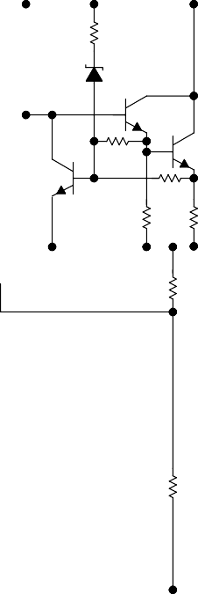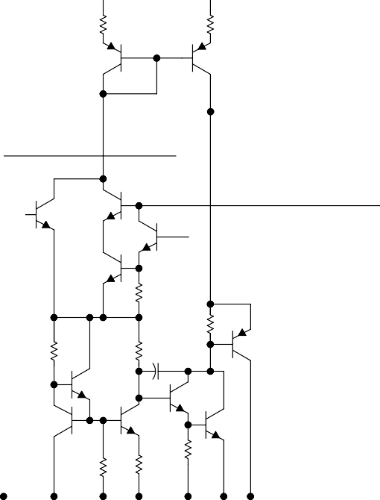

**OUTPUT**

**COMMON**

# absolute maximum ratings over virtual junction temperature range (unless otherwise noted)†

### Input voltage, VI: A7824C

All others

### . . . . . . . . . . . . . . . . . . . . . . . . . . . . . . . . . . . . . . . . . . . . . . . . . . . . . . . . . . . . . . . . . 40 V

. . . . . . . . . . . . . . . . . . . . . . . . . . . . . . . . . . . . . . . . . . . . . . . . . . . . . . . . . . . . . . . . . 35 V

### Operating virtual junction temperature, TJ . . . . . . . . . . . . . . . . . . . . . . . . . . . . . . . . . . . . . . . . . . . . . . . . . . .

150C

### Lead temperature 1,6 mm (1/16 inch) from case for 10 seconds

. . . . . . . . . . . . . . . . . . . . . . . . . . . . . .

### 260C

Storage temperature range, Tstg 65C to 150C

† Stresses beyond those listed under “absolute maximum ratings” may cause permanent damage to the device. These are stress ratings only, and functional operation of the device at these or any other conditions beyond those indicated under “recommended operating conditions” is not implied. Exposure to absolute-maximum-rated conditions for extended periods may affect device reliability.

# package thermal data (see Note 1)

|  |  |  |  |
| --- | --- | --- | --- |
| **PACKAGE** | **BOARD** | **JC** | **JA** |
| POWER-FLEX (KTE) | High K, JESD 51-5 | 3C/W | 23C/W |
| TO-220 (KC/KCS) | High K, JESD 51-5 | 3C/W | 19C/W |

NOTE 1: Maximum power dissipation is a function of TJ(max), JA, and TA. The maximum allowable power dissipation at any allowable ambient temperature is PD = (TJ(max) – TA)/JA. Operating at the absolute maximum TJ of 150C can affect reliability.

# recommended operating conditions

|  |  |  |  |  |  |
| --- | --- | --- | --- | --- | --- |
|  | | | **MIN** | **MAX** | **UNIT** |
| VI | Input voltage | A7805C | 7 | 25 | V |
| A7808C | 10.5 25 | |
| A7810C | 12.5 28 | |
| A7812C | 14.5 30 | |
| A7815C | 17.5 30 | |
| A7824C | 27 | 38 |
| IO | Output current |  | 1.5 | | A |
| TJ | Operating virtual junction temperature | A7800C series | 0 | 125 | C |

**electrical characteristics at specified virtual junction temperature, VI = 10 V, IO = 500 mA (unless otherwise noted)**

|  |  |  |  |  |  |  |  |
| --- | --- | --- | --- | --- | --- | --- | --- |
| **PARAMETER** | **TEST CONDITIONS** | | **TJ†** | **A7805C** | | | **UNIT** |
| **MIN** | **TYP** | **MAX** |
| Output voltage | IO = 5 mA to 1 A, PD  15 W | VI = 7 V to 20 V, | 25C | 4.8 | 5 | 5.2 | V |
| 0C to 125C | 4.75 |  | 5.25 |
| Input voltage regulation | VI = 7 V to 25 V | | 25C |  | 3 | 100 | mV |
| VI = 8 V to 12 V | |  | 1 | 50 |
| Ripple rejection | VI = 8 V to 18 V, | f = 120 Hz | 0C to 125C | 62 | 78 |  | dB |
| Output voltage regulation | IO = 5 mA to 1.5 A | | 25C |  | 15 | 100 | mV |
| IO = 250 mA to 750 mA | |  | 5 | 50 |
| Output resistance | f = 1 kHz | | 0C to 125C | 0.017 | | |  |
| Temperature coefficient of output voltage | IO = 5 mA | | 0C to 125C | –1.1 | | | mV/C |
| Output noise voltage | f = 10 Hz to 100 kHz | | 25C | 40 | | | V |
| Dropout voltage | IO = 1 A | | 25C | 2 | | | V |
| Bias current |  | | 25C | 4.2 8 | | | mA |
| Bias current change | VI = 7 V to 25 V | | 0C to 125C | 1.3 | | | mA |
| IO = 5 mA to 1 A | | 0.5 | | |
| Short-circuit output current |  | | 25C | 750 | | | mA |
| Peak output current |  | | 25C | 2.2 | | | A |

† Pulse-testing techniques maintain the junction temperature as close to the ambient temperature as possible. Thermal effects must be taken into account separately. All characteristics are measured with a 0.33-F capacitor across the input and a 0.1-F capacitor across the output.

# electrical characteristics at specified virtual junction temperature, VI = 14 V, IO = 500 mA (unless otherwise noted)

|  |  |  |  |  |  |  |  |
| --- | --- | --- | --- | --- | --- | --- | --- |
| **PARAMETER** | **TEST CONDITIONS** | | **TJ†** | **A7808C** | | | **UNIT** |
| **MIN** | **TYP** | **MAX** |
| Output voltage | IO = 5 mA to 1 A, PD  15 W | VI = 10.5 V to 23 V, | 25C | 7.7 | 8 | 8.3 | V |
| 0C to 125C | 7.6 |  | 8.4 |
| Input voltage regulation | VI = 10.5 V to 25 V | | 25C |  | 6 | 160 | mV |
| VI = 11 V to 17 V | |  | 2 | 80 |
| Ripple rejection | VI = 11.5 V to 21.5 V, f = 120 Hz | | 0C to 125C | 55 | 72 |  | dB |
| Output voltage regulation | IO = 5 mA to 1.5 A | | 25C |  | 12 | 160 | mV |
| IO = 250 mA to 750 mA | |  | 4 | 80 |
| Output resistance | f = 1 kHz | | 0C to 125C | 0.016 | | |  |
| Temperature coefficient of output voltage | IO = 5 mA | | 0C to 125C | –0.8 | | | mV/C |
| Output noise voltage | f = 10 Hz to 100 kHz | | 25C | 52 | | | V |
| Dropout voltage | IO = 1 A | | 25C | 2 | | | V |
| Bias current |  | | 25C | 4.3 8 | | | mA |
| Bias current change | VI = 10.5 V to 25 V | | 0C to 125C | 1 | | | mA |
| IO = 5 mA to 1 A | | 0.5 | | |
| Short-circuit output current |  | | 25C | 450 | | | mA |
| Peak output current |  | | 25C | 2.2 | | | A |

† Pulse-testing techniques maintain the junction temperature as close to the ambient temperature as possible. Thermal effects must be taken into account separately. All characteristics are measured with a 0.33-F capacitor across the input and a 0.1-F capacitor across the output.

# electrical characteristics at specified virtual junction temperature, VI = 17 V, IO = 500 mA (unless otherwise noted)

|  |  |  |  |  |  |  |  |
| --- | --- | --- | --- | --- | --- | --- | --- |
| **PARAMETER** | **TEST CONDITIONS** | | **TJ†** | **A7810C** | | | **UNIT** |
| **MIN** | **TYP** | **MAX** |
| Output voltage | IO = 5 mA to 1 A, PD  15 W | VI = 12.5 V to 25 V, | 25C | 9.6 | 10 | 10.4 | V |
| 0C to 125C | 9.5 | 10 | 10.5 |
| Input voltage regulation | VI = 12.5 V to 28 V | | 25C |  | 7 | 200 | mV |
| VI = 14 V to 20 V | |  | 2 | 100 |
| Ripple rejection | VI = 13 V to 23 V, | f = 120 Hz | 0C to 125C | 55 | 71 |  | dB |
| Output voltage regulation | IO = 5 mA to 1.5 A | | 25C |  | 12 | 200 | mV |
| IO = 250 mA to 750 mA | |  | 4 | 100 |
| Output resistance | f = 1 kHz | | 0C to 125C | 0.018 | | |  |
| Temperature coefficient of output voltage | IO = 5 mA | | 0C to 125C | –1 | | | mV/C |
| Output noise voltage | f = 10 Hz to 100 kHz | | 25C | 70 | | | V |
| Dropout voltage | IO = 1 A | | 25C | 2 | | | V |
| Bias current |  | | 25C | 4.3 8 | | | mA |
| Bias current change | VI = 12.5 V to 28 V | | 0C to 125C | 1 | | | mA |
| IO = 5 mA to 1 A | | 0.5 | | |
| Short-circuit output current |  | | 25C | 400 | | | mA |
| Peak output current |  | | 25C | 2.2 | | | A |

† Pulse-testing techniques maintain the junction temperature as close to the ambient temperature as possible. Thermal effects must be taken into account separately. All characteristics are measured with a 0.33-F capacitor across the input and a 0.1-F capacitor across the output.

# electrical characteristics at specified virtual junction temperature, VI = 19 V, IO = 500 mA (unless otherwise noted)

|  |  |  |  |  |  |  |  |
| --- | --- | --- | --- | --- | --- | --- | --- |
| **PARAMETER** | **TEST CONDITIONS** | | **TJ†** | **A7812C** | | | **UNIT** |
| **MIN** | **TYP** | **MAX** |
| Output voltage | IO = 5 mA to 1 A, PD  15 W | VI = 14.5 V to 27 V, | 25C | 11.5 | 12 | 12.5 | V |
| 0C to 125C | 11.4 |  | 12.6 |
| Input voltage regulation | VI = 14.5 V to 30 V | | 25C |  | 10 | 240 | mV |
| VI = 16 V to 22 V | |  | 3 | 120 |
| Ripple rejection | VI = 15 V to 25 V, | f = 120 Hz | 0C to 125C | 55 | 71 |  | dB |
| Output voltage regulation | IO = 5 mA to 1.5 A | | 25C |  | 12 | 240 | mV |
| IO = 250 mA to 750 mA | |  | 4 | 120 |
| Output resistance | f = 1 kHz | | 0C to 125C | 0.018 | | |  |
| Temperature coefficient of output voltage | IO = 5 mA | | 0C to 125C | –1 | | | mV/C |
| Output noise voltage | f = 10 Hz to 100 kHz | | 25C | 75 | | | V |
| Dropout voltage | IO = 1 A | | 25C | 2 | | | V |
| Bias current |  | | 25C | 4.3 8 | | | mA |
| Bias current change | VI = 14.5 V to 30 V | | 0C to 125C | 1 | | | mA |
| IO = 5 mA to 1 A | | 0.5 | | |
| Short-circuit output current |  | | 25C | 350 | | | mA |
| Peak output current |  | | 25C | 2.2 | | | A |

† Pulse-testing techniques maintain the junction temperature as close to the ambient temperature as possible. Thermal effects must be taken into account separately. All characteristics are measured with a 0.33-F capacitor across the input and a 0.1-F capacitor across the output.

# electrical characteristics at specified virtual junction temperature, VI = 23 V, IO = 500 mA (unless otherwise noted)

|  |  |  |  |  |  |  |  |
| --- | --- | --- | --- | --- | --- | --- | --- |
| **PARAMETER** | **TEST CONDITIONS** | | **TJ†** | **A7815C** | | | **UNIT** |
| **MIN** | **TYP** | **MAX** |
| Output voltage | IO = 5 mA to 1 A, PD  15 W | VI = 17.5 V to 30 V, | 25C | 14.4 | 15 | 15.6 | V |
| 0C to 125C | 14.25 |  | 15.75 |
| Input voltage regulation | VI = 17.5 V to 30 V | | 25C |  | 11 | 300 | mV |
| VI = 20 V to 26 V | |  | 3 | 150 |
| Ripple rejection | VI = 18.5 V to 28.5 V, f = 120 Hz | | 0C to 125C | 54 | 70 |  | dB |
| Output voltage regulation | IO = 5 mA to 1.5 A | | 25C |  | 12 | 300 | mV |
| IO = 250 mA to 750 mA | |  | 4 | 150 |
| Output resistance | f = 1 kHz | | 0C to 125C | 0.019 | | |  |
| Temperature coefficient of output voltage | IO = 5 mA | | 0C to 125C | –1 | | | mV/C |
| Output noise voltage | f = 10 Hz to 100 kHz | | 25C | 90 | | | V |
| Dropout voltage | IO = 1 A | | 25C | 2 | | | V |
| Bias current |  | | 25C | 4.4 8 | | | mA |
| Bias current change | VI = 17.5 V to 30 V | | 0C to 125C | 1 | | | mA |
| IO = 5 mA to 1 A | | 0.5 | | |
| Short-circuit output current |  | | 25C | 230 | | | mA |
| Peak output current |  | | 25C | 2.1 | | | A |

† Pulse-testing techniques maintain the junction temperature as close to the ambient temperature as possible. Thermal effects must be taken into account separately. All characteristics are measured with a 0.33-F capacitor across the input and a 0.1-F capacitor across the output.

# electrical characteristics at specified virtual junction temperature, VI = 33 V, IO = 500 mA (unless otherwise noted)

|  |  |  |  |  |  |  |  |
| --- | --- | --- | --- | --- | --- | --- | --- |
| **PARAMETER** | **TEST CONDITIONS** | | **TJ†** | **A7824C** | | | **UNIT** |
| **MIN** | **TYP** | **MAX** |
| Output voltage | IO = 5 mA to 1 A, PD  15 W | VI = 27 V to 38 V, | 25C | 23 | 24 | 25 | V |
| 0C to 125C | 22.8 |  | 25.2 |
| Input voltage regulation | VI = 27 V to 38 V | | 25C |  | 18 | 480 | mV |
| VI = 30 V to 36 V | |  | 6 | 240 |
| Ripple rejection | VI = 28 V to 38 V, | f = 120 Hz | 0C to 125C | 50 | 66 |  | dB |
| Output voltage regulation | IO = 5 mA to 1.5 A | | 25C |  | 12 | 480 | mV |
| IO = 250 mA to 750 mA | |  | 4 | 240 |
| Output resistance | f = 1 kHz | | 0C to 125C | 0.028 | | |  |
| Temperature coefficient of output voltage | IO = 5 mA | | 0C to 125C | –1.5 | | | mV/C |
| Output noise voltage | f = 10 Hz to 100 kHz | | 25C | 170 | | | V |
| Dropout voltage | IO = 1 A | | 25C | 2 | | | V |
| Bias current |  | | 25C | 4.6 8 | | | mA |
| Bias current change | VI = 27 V to 38 V | | 0C to 125C | 1 | | | mA |
| IO = 5 mA to 1 A | | 0.5 | | |
| Short-circuit output current |  | | 25C | 150 | | | mA |
| Peak output current |  | | 25C | 2.1 | | | A |

† Pulse-testing techniques maintain the junction temperature as close to the ambient temperature as possible. Thermal effects must be taken into account separately. All characteristics are measured with a 0.33-F capacitor across the input and a 0.1-F capacitor across the output.

# APPLICATION INFORMATION

**+V**



**0.33** **F**

**+VO**

**0.1** **F**

**A78xx**

**Figure 1. Fixed-Output Regulator**

**+ IN**



**A78xx**

**IL**



**VI**

**COM**

**–**

**OUT**

**G**

**–VO**

## Figure 2. Positive Regulator in Negative Configuration (VI Must Float)

**Input ut**



**Outp**

**IO**

**R1**

**0.33** **F**

**0.1** **F**

**R2**

**A78xx**

NOTE A: The following formula is used when Vxx is the nominal output voltage (output to common) of the fixed regulator:

V Vxx Vxx I R2

O R1 Q

## Figure 3. Adjustable-Output Regulator

**Input**



**A78xx**

**0.33** **F**

**VO(Reg)**

**R1**

**Output**



**IO**

**IO = (VO/R1) + IO Bias Current**

**Figure 4. Current Regulator**

# APPLICATION INFORMATION

**1N4001**

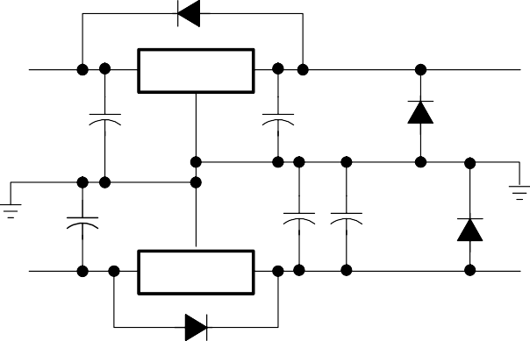**20-V Input**

**0.33** **F**

**A7815C**

**0.1** **F 1N4001**

**VO = 15 V**

**2** **F**

**–20-V Input** **A7915C**

**1** **F**

* 1. **F**

**1N4001**

**VO = –15 V**

**1N4001**

**Figure 5. Regulated Dual Supply**

# operation with a load common to a voltage of opposite polarity

### In many cases, a regulator powers a load that is not connected to ground but, instead, is connected to a voltage source of opposite polarity (e.g., operational amplifiers, level-shifting circuits, etc.). In these cases, a clamp diode should be connected to the regulator output as shown in Figure 6. This protects the regulator from output polarity reversals during startup and short-circuit operation.

**+VI +VO**



**1N4001**

**or Equivalent**

**A78xx**

**–VO**

**Figure 6. Output Polarity-Reversal-Protection Circuit**

# reverse-bias protection

### Occasionally, the input voltage to the regulator can collapse faster than the output voltage. This can occur, for example, when the input supply is crowbarred during an output overvoltage condition. If the output voltage is greater than approximately 7 V, the emitter-base junction of the series-pass element (internal or external) could break down and be damaged. To prevent this, a diode shunt can be used as shown in Figure 7.

**VI +VO**



**A78xx**

**Figure 7. Reverse-Bias-Protection Circuit**

**MECHANICAL DATA**

MPFM001E – OCTOBER 1994 – REVISED JANUARY 2001

**KTE (R-PSFM-G3) PowerFLEX** **PLASTIC FLANGE-MOUNT**



**0.375 (9,52)**

**0.365 (9,27)**

**0.360 (9,14)**

**0.350 (8,89)**

**0.220 (5,59) NOM**

**0.080 (2,03)**

**0.070 (1,78)**

**0.050 (1,27)**

**0.040 (1,02)**

**0.010 (0,25) NOM**

**0.295 (7,49) NOM**

**0.420 (10,67)**

**0.410 (10,41)**

**0.360 (9,14)**

**0.350 (8,89)**

**Thermal Tab (See Note C)**

**0.320 (8,13)**

**0.310 (7,87)**

**1**

**3**

**0.100 (2,54)**

**0.025 (0,63)**

**0.031 (0,79)**

**0.010 (0,25)**

**Seating Plane**

**0.004 (0,10)**

M

**0.005 (0,13)**

**0.200 (5,08) 0.001 (0,03)**

**0.010 (0,25) NOM**

**Gage Plane**

**0.041 (1,04)**

**0.031 (0,79)**

**3****– 6**

**0.010 (0,25)**

**4073375/F 12/00**

NOTES: A. All linear dimensions are in inches (millimeters).

* + 1. This drawing is subject to change without notice.
    2. The center lead is in electrical contact with the thermal tab.
    3. Dimensions do not include mold protrusions, not to exceed 0.006 (0,15).
    4. Falls within JEDEC MO-169

PowerFLEX is a trademark of Texas Instruments.

 

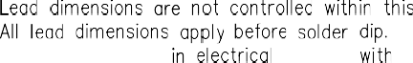



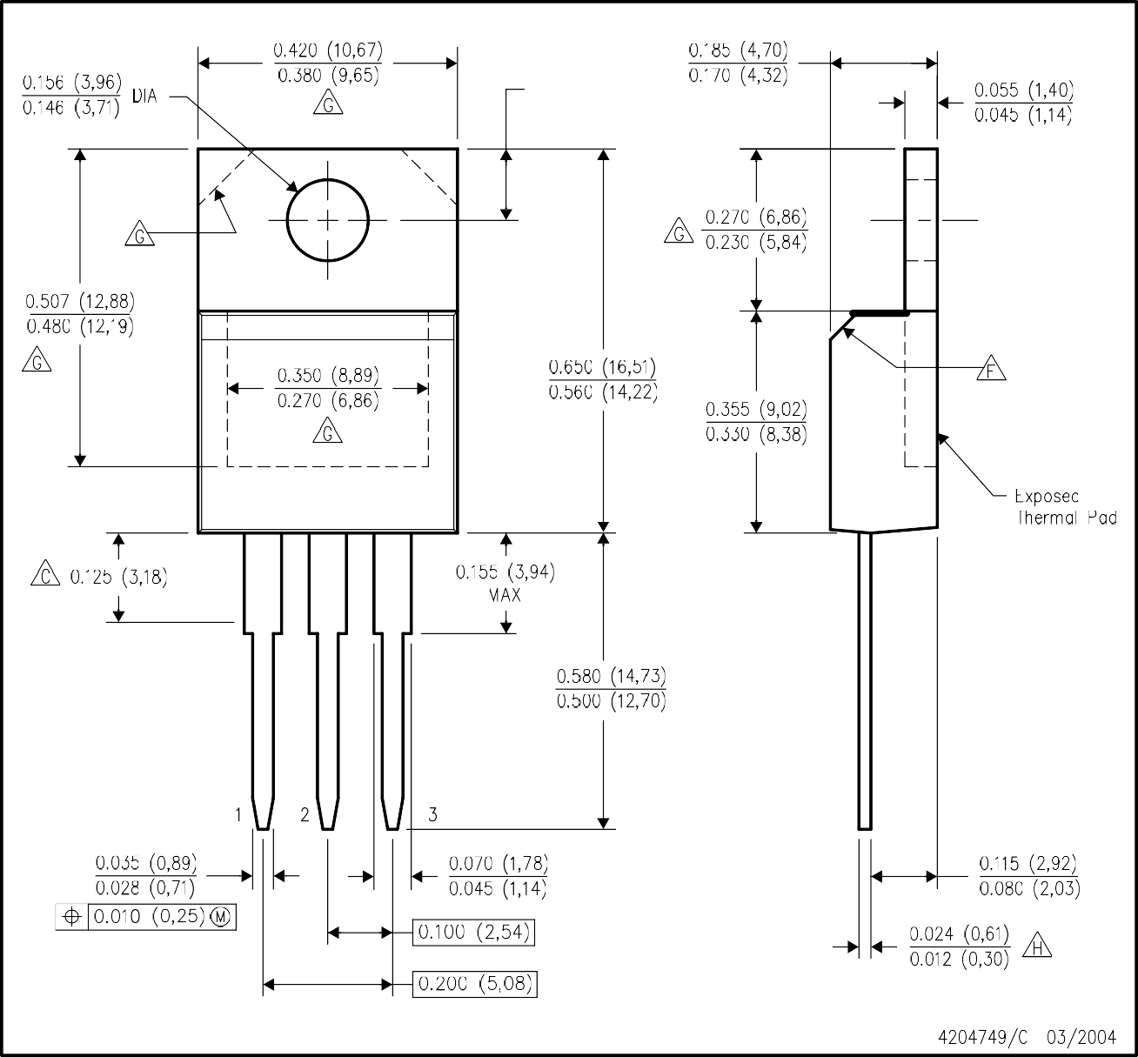

  





 





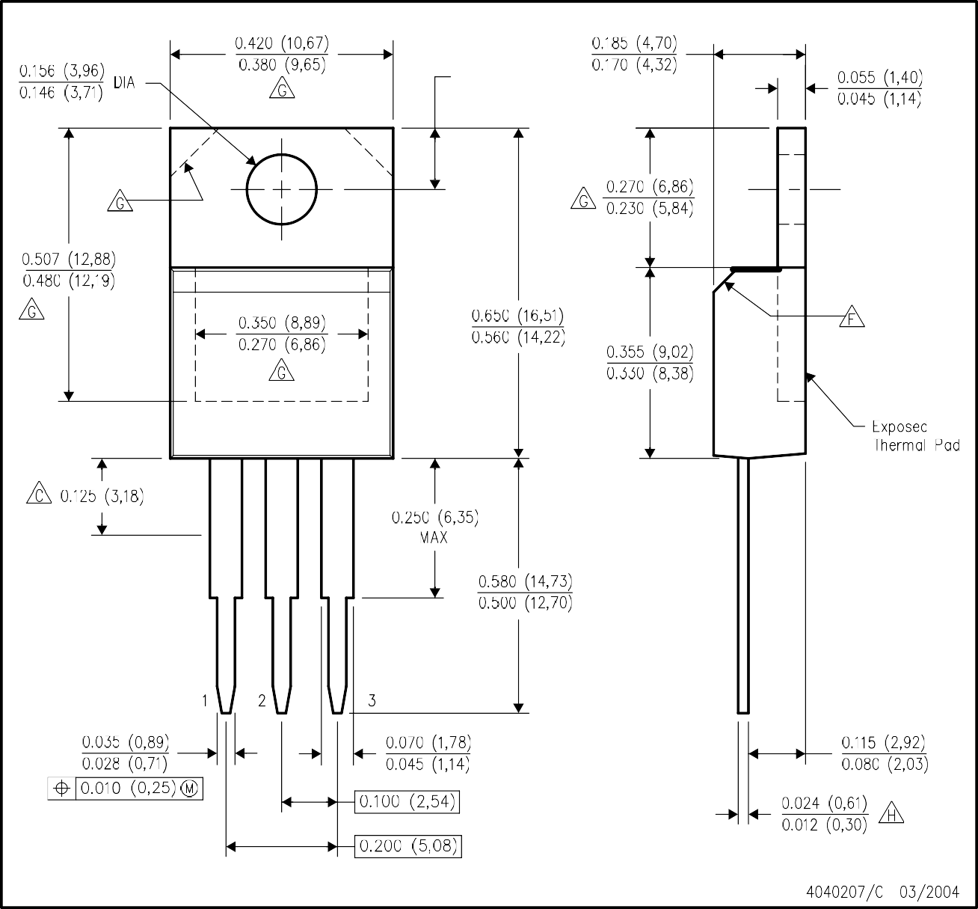

### 





**IMPORTANT NOTICE**

#### Texas Instruments Incorporated and its subsidiaries (TI) reserve the right to make corrections, modifications, enhancements, improvements, and other changes to its products and services at any time and to discontinue any product or service without notice. Customers should obtain the latest relevant information before placing orders and should verify that such information is current and complete. All products are sold subject to TI’s terms and conditions of sale supplied at the time of order acknowledgment.

TI warrants performance of its hardware products to the specifications applicable at the time of sale in accordance with TI’s standard warranty. Testing and other quality control techniques are used to the extent TI deems necessary to support this warranty. Except where mandated by government requirements, testing of all parameters of each product is not necessarily performed.

#### TI assumes no liability for applications assistance or customer product design. Customers are responsible for their products and applications using TI components. To minimize the risks associated with customer products and applications, customers should provide adequate design and operating safeguards.

TI does not warrant or represent that any license, either express or implied, is granted under any TI patent right, copyright, mask work right, or other TI intellectual property right relating to any combination, machine, or process in which TI products or services are used. Information published by TI regarding third-party products or services does not constitute a license from TI to use such products or services or a warranty or endorsement thereof. Use of such information may require a license from a third party under the patents or other intellectual property of the third party, or a license from TI under the patents or other intellectual property of TI.

#### Reproduction of information in TI data books or data sheets is permissible only if reproduction is without alteration and is accompanied by all associated warranties, conditions, limitations, and notices. Reproduction of this information with alteration is an unfair and deceptive business practice. TI is not responsible or liable for such altered documentation.

Resale of TI products or services with statements different from or beyond the parameters stated by TI for that product or service voids all express and any implied warranties for the associated TI product or service and is an unfair and deceptive business practice. TI is not responsible or liable for any such statements.

#### Following are URLs where you can obtain information on other Texas Instruments products and application solutions:

|  |  |  |  |
| --- | --- | --- | --- |
| **Products** |  | **Applications** |  |
| Amplifiers | amplifier.ti.com | Audio | [www.ti.com/audio](http://www.ti.com/audio) |
| Data Converters | dataconverter.ti.com | Automotive | [www.ti.com/automotive](http://www.ti.com/automotive) |
| DSP | dsp.ti.com | Broadband | [www.ti.com/broadband](http://www.ti.com/broadband) |
| Interface | interface.ti.com | Digital Control | [www.ti.com/digitalcontrol](http://www.ti.com/digitalcontrol) |
| Logic | logic.ti.com | Military | [www.ti.com/military](http://www.ti.com/military) |
| Power Mgmt | power.ti.com | Optical Networking | [www.ti.com/opticalnetwork](http://www.ti.com/opticalnetwork) |
| Microcontrollers | microcontroller.ti.com | Security | [www.ti.com/security](http://www.ti.com/security) |
|  |  | Telephony  Video & Imaging | [www.ti.com/telephony](http://www.ti.com/telephony)  [www.ti.com/video](http://www.ti.com/video) |
|  |  | Wireless | [www.ti.com/wireless](http://www.ti.com/wireless) |

Mailing Address: Texas Instruments

#### Post Office Box 655303 Dallas, Texas 75265

Copyright  2004, Texas Instruments Incorporated